University Of Central Punjab
Department of Computer Science

Sky Path
Drone Navigation & Delivery System

Final Project Documentation
Data Structures & Algorithms

Submitted By | Muhammad Haseeb
Date | 14-06-2026

1. Introduction
Sky Path is a console-based Drone Navigation and Delivery Management System developed in Java as a final project for the Data Structures and Algorithms course. The system simulates a real-world drone delivery network in which multiple drones are managed, delivery missions are created and prioritized, optimal flight routes are calculated, and obstacles in the airspace are handled dynamically.

The primary objective of this project is to demonstrate the practical application of core data structures — such as graphs, queues, priority queues, stacks, binary search trees, and hash maps — in solving a real and relatable problem. Instead of studying these structures in isolation, SkyPath integrates all of them into a single working system.

Project Objectives
- Design and implement a multi-drone delivery network using DSA concepts
- Apply Dijkstra’s Algorithm to calculate shortest flight paths in a weighted graph
- Use a Priority Queue (Min-Heap) to schedule deliveries based on urgency
- Implement a FIFO Queue to maintain the order of incoming delivery requests
- Use a Stack for backtracking when obstacles are detected on the flight route
- Store completed missions in a Binary Search Tree (BST) for efficient lookup
- Manage drone fleet using a HashMap for O(1) access

Problem Statement
As drone delivery becomes increasingly realistic in modern logistics, there is a growing need for intelligent systems that can plan efficient routes, manage multiple drones, handle real-time obstacles, and maintain organized records of all deliveries. Sky Path addresses this problem in a simulated environment using fundamental data structures.

2. Data Structures Used
The table below summarizes every data structure used in the project, the Java class that implements it, and its specific role in the system.

Data Structure | Java Class | Role in System
Weighted Graph | Graph.java | Airspace map — waypoints as nodes, distances as edge weights
Dijkstra's Algorithm | DijkstraAlgorithm.java | Shortest delivery route with optional blocked-node support
FIFO Queue | DeliveryQueue.java | Holds incoming delivery orders in First-In-First-Out order
Priority Queue | MissionScheduler.java | Schedules missions by urgency: Emergency (1) > Normal (2) > Low (3)
Stack | RouteBacktracker.java | Tracks visited waypoints for backtracking around obstacles
Binary Search Tree | DeliveryHistoryBST.java | Stores completed missions sorted by Mission ID — O(log n) search
HashMap | DroneRegistry.java | Maps Drone ID strings to Drone objects — O(1) lookup
ArrayList | Main.java | Maintains the list of active (in-progress) missions

Graph — Airspace Map
The airspace is modelled as an undirected weighted graph. There are 8 waypoints: Warehouse, CityCenter, Hospital, Mall, Airport, University, Park, and Stadium. Each waypoint is a node, and each bidirectional route between two waypoints is a weighted edge representing distance in kilometres. The adjacency list is stored inside a HashMap<String, List<Edge>>, giving O(1) waypoint lookup.

Dijkstra’s Algorithm
Dijkstra’s shortest-path algorithm is applied every time a mission is assigned to a drone. It uses a PriorityQueue<NodeDistance> (min-heap by distance) internally. It also accepts an optional Set<String> of blocked nodes, so the same algorithm is reused by the RouteBacktracker to find alternate paths that avoid detected obstacles.

Queue — Pending Orders
Incoming delivery missions are added to a LinkedList-backed Queue (FIFO). This preserves the order in which customers placed orders. When the dispatcher assigns missions, all pending items are drained into the MissionScheduler, which re-orders them by priority, selects the most urgent mission, and pushes the remaining ones back to the queue.

Priority Queue — Mission Scheduler
The MissionScheduler wraps Java’s built-in PriorityQueue with a comparator on priorityLevel. A lower number means higher urgency (1 = EMERGENCY). This ensures that even if a low-priority order was placed first, an emergency order placed later will jump to the front.

Stack — Route Backtracker
The RouteBacktracker uses a Stack<String> to record each waypoint the drone has already visited. When an obstacle is detected at a certain waypoint on the planned route, the drone pops the previous waypoint from the stack, adds the blocked node to a blocked set, and calls Dijkstra again from that previous waypoint to the destination — effectively rerouting around the obstacle.

Binary Search Tree — Delivery History
Completed missions are stored in a custom BST keyed by missionId (integer). Insertion and search both run in O(log n) on average. The BST also supports an in-order traversal that prints all completed missions sorted by ID — useful for audit and reporting purposes.

3. System Architecture & Class Design
SkyPath is organized into 10 Java classes. Each class is responsible for one specific concern, following the Single Responsibility Principle.

Class | Responsibility
Main.java | Entry point. Initializes all data structures, sets up airspace, runs the interactive menu loop.
Graph.java | Stores the airspace as an adjacency list. Provides addWaypoint(), addEdge(), getNeighbors(), getAllWaypoints().
DijkstraAlgorithm.java | Stateless utility class. findShortestPath() returns a Result object with ordered waypoints and total distance.
Drone.java | Represents a single drone with ID, battery level, payload capacity, location, and status.
DroneRegistry.java | HashMap-backed fleet manager. findAvailableDrone() filters by status, payload, and minimum battery (>20%).
DeliveryMission.java | Data class holding all delivery order info — route, distance, assigned drone, priority, and status.
DeliveryQueue.java | FIFO wrapper around LinkedList<DeliveryMission>. Provides enqueue(), dequeue(), displayPendingOrders().
MissionScheduler.java | Priority-queue wrapper ordering missions by priorityLevel ascending.
BSTNode.java | Node class for the delivery history BST. Holds a DeliveryMission and left/right child pointers.
DeliveryHistoryBST.java | BST with insert(), search(), and displayInorder() recursive in-order traversal.
RouteBacktracker.java | Uses a Stack to record visited waypoints. handleObstacle() pops the last safe waypoint and re-runs Dijkstra.

4. Features & System Workflow

Airspace Setup
On startup, Main.setupAirspace() automatically creates 8 waypoints and 13 bidirectional weighted edges. This represents a realistic small-city delivery network. The user does not need to enter any routes manually.

Menu Options
The system offers a 12-option interactive menu:
- Option 1 — Register Drone: Adds a new drone with ID, battery, location, and payload capacity to the HashMap registry.
- Option 2 — View All Drones: Displays every registered drone with its current status and battery.
- Option 3 — Create Delivery Mission: Accepts source, destination, weight, and priority from the user. Validates all inputs and enqueues the mission.
- Option 4 — View Pending Orders: Lists all missions currently waiting in the FIFO queue.
- Option 5 — Assign Mission: Drains the queue into the priority scheduler, picks the most urgent mission, finds an eligible drone, and computes the delivery route using Dijkstra.
- Option 6 — Simulate Delivery: Animates the drone flying waypoint-by-waypoint along the route, deducts battery, and moves the drone to the destination.
- Option 7 — Simulate Obstacle: Lets the user block a waypoint on the current route and triggers the stack-based backtracker to reroute.
- Option 8 — Complete Mission: Marks a mission COMPLETED, frees the drone, and inserts the mission into the BST history.
- Option 9 — Search Completed Mission (BST): O(log n) search by Mission ID in the BST.
- Option 10 — Display Delivery History: In-order BST traversal prints all completed missions sorted by ID.
- Option 11 — Drone Registry Overview: Shows total count and full details of all drones.
- Option 12 — Exit.

Obstacle Handling Flow
When an obstacle is detected mid-route, the system executes the following sequence:
- Pushes each waypoint onto the Stack as the drone moves along the original route.
- On detecting a blocked waypoint, pops the most recent safe waypoint.
- Adds the blocked node to a set and calls Dijkstra from the safe waypoint to the destination, excluding blocked nodes.
- If an alternate route exists, the mission route is updated; otherwise the mission is flagged as unable to continue.

5. Sample Execution Walkthrough
The following walkthrough demonstrates a typical session with SkyPath from drone registration to mission completion.

Step / User Action | System Response
Register Drone D1 at Warehouse Battery 90%, Capacity 10 kg | Drone D1 saved to DroneRegistry HashMap.
Create Mission 101 Warehouse → Hospital, 3 kg, Priority 2 (Normal) | Mission enqueued in FIFO DeliveryQueue.
Create Mission 102 Mall → Stadium, 2 kg, Priority 1 (Emergency) | Mission enqueued; queue now has 2 missions.
Assign Mission (Option 5) | Scheduler picks Mission 102 (Emergency). Dijkstra computes Mall → Stadium = 5 km. Drone D1 assigned.
Simulate Delivery (Option 6) | Drone flies: Mall → Stadium. Battery drops from 90% to 85%.
Simulate Obstacle at Stadium on M101 | Stack backtracks to Mall. Dijkstra reroutes: Mall → Hospital → Park → Stadium (12 km).
Complete Mission 102 (Option 8) | Status set to COMPLETED. Mission inserted into BST. Drone D1 returns to AVAILABLE.
Search Mission 102 (Option 9) | BST traverses tree, finds and displays Mission 102 in O(log n).

6. Time & Space Complexity Analysis

Operation | Complexity | Explanation
Drone Lookup (HashMap) | O(1) avg. | HashMap provides constant-time get/put
Find Available Drone | O(d) | Linear scan through d registered drones
Enqueue Delivery Mission | O(1) | LinkedList add at tail
Priority Scheduling | O(n log n) | n missions inserted then polled from min-heap
Dijkstra Shortest Path | O((V+E) log V) | V waypoints, E edges, min-heap priority queue
BST Insert / Search | O(log n) avg. | Balanced on average for random Mission IDs
BST In-order Display | O(n) | Visits every node exactly once
Stack Push / Pop | O(1) | Java Stack operations are constant time
Route Backtracking | O((V+E) log V) | Dominated by the second Dijkstra call

7. Conclusion & Learning Outcomes
SkyPath successfully demonstrates how multiple data structures can collaborate within a single application to solve a realistic engineering problem. The project moved beyond textbook exercises by requiring each structure to interact with the others — for example, the Priority Queue feeds results into Dijkstra, Dijkstra’s output is stored in a FIFO Queue, and completed missions flow into a BST.

Through the development of this project, the following key skills were practiced and reinforced:
- Implementing graph-based algorithms (Dijkstra) from first principles in Java.
- Understanding when to use a FIFO Queue versus a Priority Queue and the trade-offs involved.
- Appreciating how a Stack naturally models backtracking behavior in navigation problems.
- Building a BST manually — with recursive insert, search, and traversal — rather than relying on built-in tree structures.
- Designing a clean, modular Java system with distinct responsibilities per class.

This project demonstrates that data structures are not isolated academic concepts but rather composable building blocks for solving complex, real-world problems efficiently.

Output:

Drone Registration:

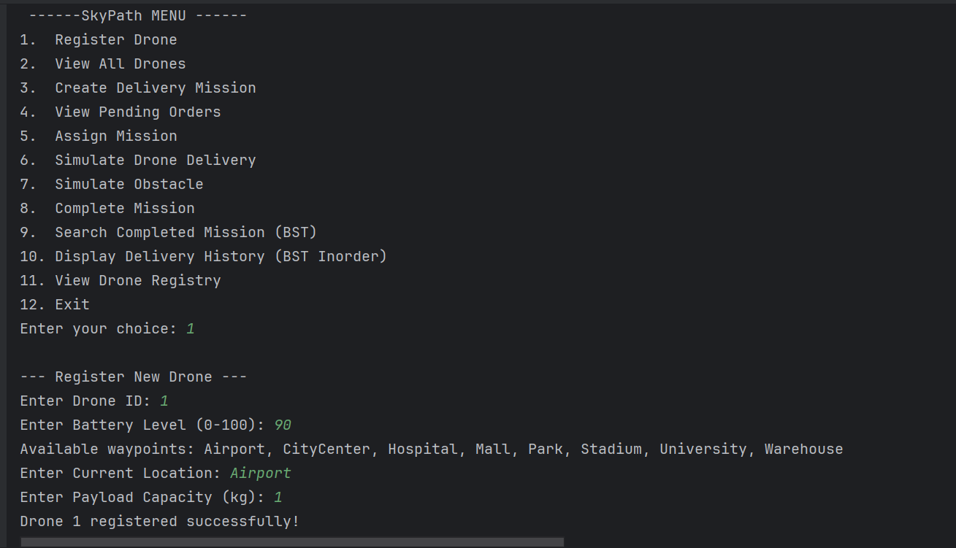

2:

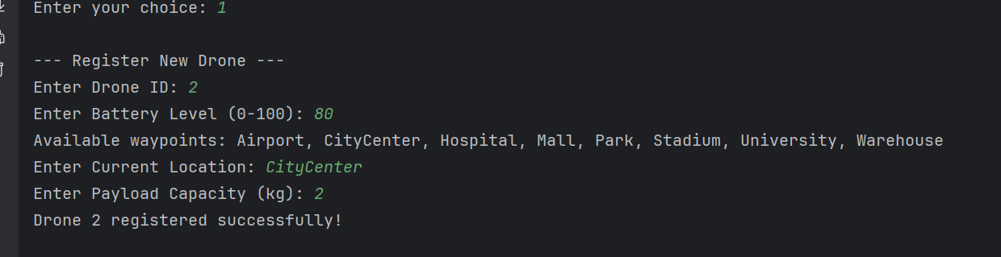

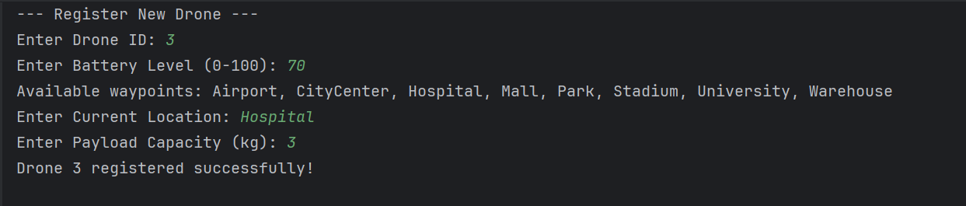

View Drones:

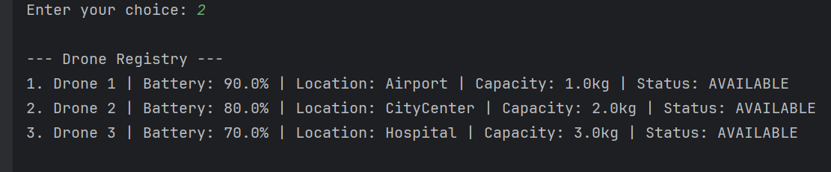

Create Delivery Mission:

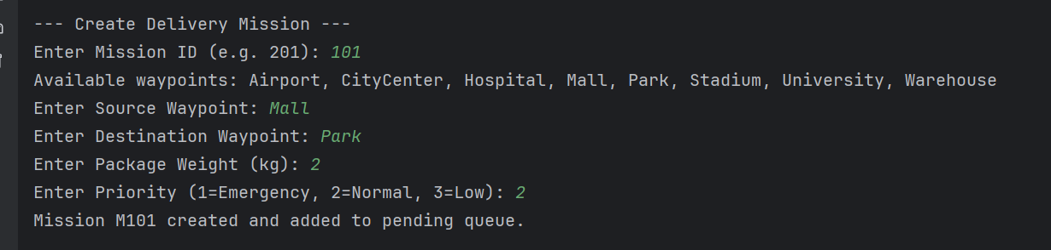

Pending Delivery Order:

Mission Assigned:

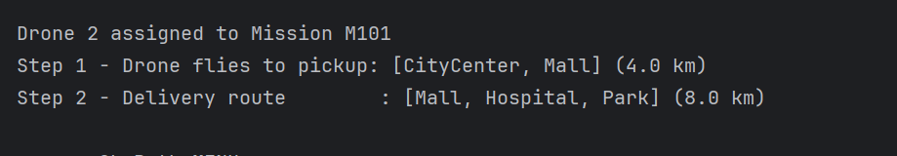

Drone Delivery:

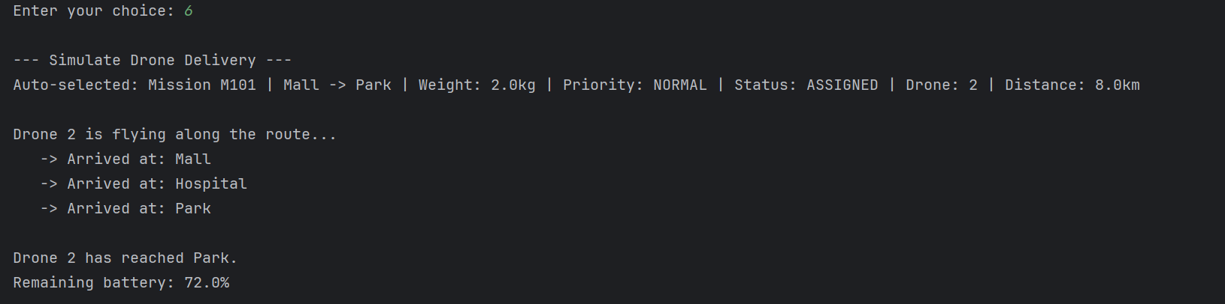

Obsatacle:

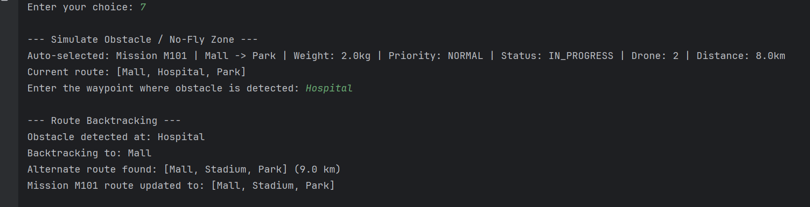

Mission Completed:

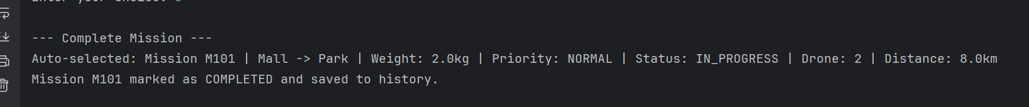

Search Mission:

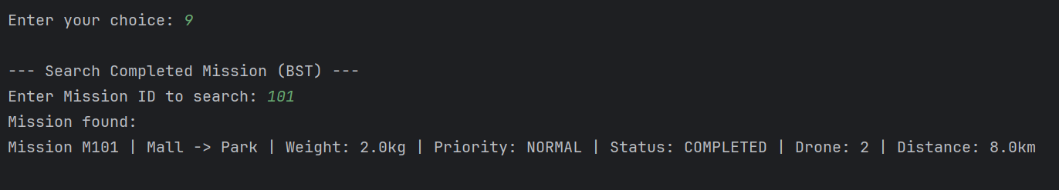

Display Delivery History:

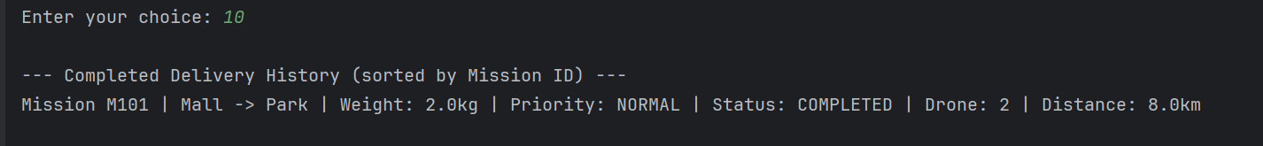

Drone Registery:

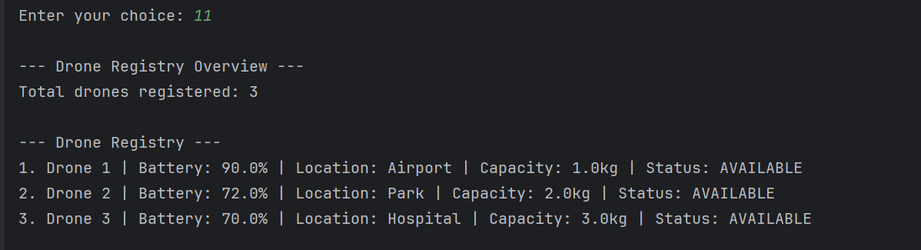
Exit:

